Version 2026-04-01 17:35, Eric Pohl

Preparation (discharge)
The discharge measurements using the dilution method require strict preparation to ensure useful results. The dilution method depends on measuring a tracer concentration in the stream water over time (concentration curve). By relating the injected tracer amount (weight) to the concentration curve, one can directly calculate the discharge using the formula $Q=M/A$ (see Chapter 1.2).
For the fluorometer, the problem in this approach is that the instrument is measuring only the light intensity of the excited tracer dye, not the actual concentration of color. The instrument measures the intensity as an electrical signal [mV]. This mV signal needs to be related to a known concentration. Therefore, it is of fundamental importance to calibrate the instrument. This requires prepared amounts of tracer (calibration vials) that are measured by the instrument in the actual stream water. It is important to perform the calibration in the actual stream water because temperature and sediment concentration can have a strong impact on how much light the tracer emits and how well this light can reach the photo detector of the instrument.
The actual measurement color and the prepared calibration vials must come from the same stock/base solution. The base solution is obtained by solving 50 g or 100 g of a tracer (usually Sodium-Fluorescein “Uranine”) in exactly 1L of water (can be tap water). This solution will be used to make the actual color injections for the measurement, as well as to derive the calibration liquid via a dilution series. The individual steps are explained in the following.
Before 2025, calibration liquid was prepared to have exactly 250 µg of tracer material in the calibration vials. As of 2025, we have adjusted the approach that allows for a much quicker preparation but it requires to keep track of some information (Excel file). Inside the materials folder, you will find the Excel file “05 - Lab preparation v 2025-07-15 [EN].xlsx” that can be used to prepare your calibration liquid. The following description explains only this new method.

Base solution
The base solution is prepared using a 1L or 2L mixing flask (Figure 1). The tracer needs to be solved in this mixing flask. A good amount for most Central Asian sites is 50 g of tracer. This usually results in enough tracer for 1 or 2 glacier field expedition, where a usual injection amount is between 10 g (we weigh the liquid later) and 100 g. The working steps are:
- Place mixing flask on scale (0.1 g precision is sufficient) with a measurement range of 3 kg (the flask, 1 or 2 liters of water and tracer can weigh more than 2 kg!!!)
- Tare (set weight to 0 with the mixing flask on the scale)
- Place funnel
- Open tracer bag (Sodium-Fluoresceine powder) and add tracer until you reach the desired amount.
  - It is not important to be precisely at 50 g or 100 g, but you should note down the value in a copy of your 05 - Lab preparation v 2025-07-15 [EN].xlsx file.
- Add slowly water until you reach around 2/3 filling
- Make sure no color (powder) is stuck at the opening of the flask as this can prevent it from sealing
- Solve the color by slowly by moving the bottle in circles (don’t shake! This will produce a lot of air bubbles)
  - This can take a long time – plan an hour for this step alone in total
  - Check if there is still color at the bottom of the bottle (the brighter powder can easily be spotted)
  - Tilt the bottle to see if the color when running down the sides (inside) still has unsolved salt in it or if it is all homogenous
- Once solved, fill the flask slowly until the 1L or 2L marker
- Measure the weight of the mixing flask with the 1L or 2L of volume (without the cap)
  - This is the density of the solution (we fill this into the Excel sheet)
- You can now fill this base solution into a PET bottle (wide neck) – this is from now on your source of color for all folowing steps
- Clean the mixing flask

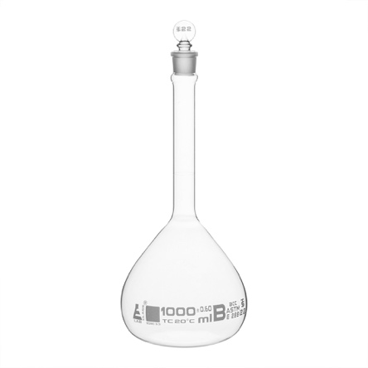
Figure 1: Mixing flask (1L).
Required materials and tools:
- Mixing flask (1L or 2L) with cap
- Scale (2 kg or 3 kg load, with around 0.1 g precision – precision not very important)
- Computer with a copy of the Excel file 05 - Lab preparation v 2025-07-15 [EN].xlsx
- Funnel (to get the color into the flask)
- Tracer (Sodium-Fluoresceine in powder form) – 50 g or 100 g (50 g usually more than sufficient for small and medium sized glaciers)
- Squirt bottle (to slowly fill the mixing flask to the volume marker)
- Water (tap water) – you can use a 1L cyclinder for the fast filling (2/3 of the mixing flask)
- Spatula or small spoon
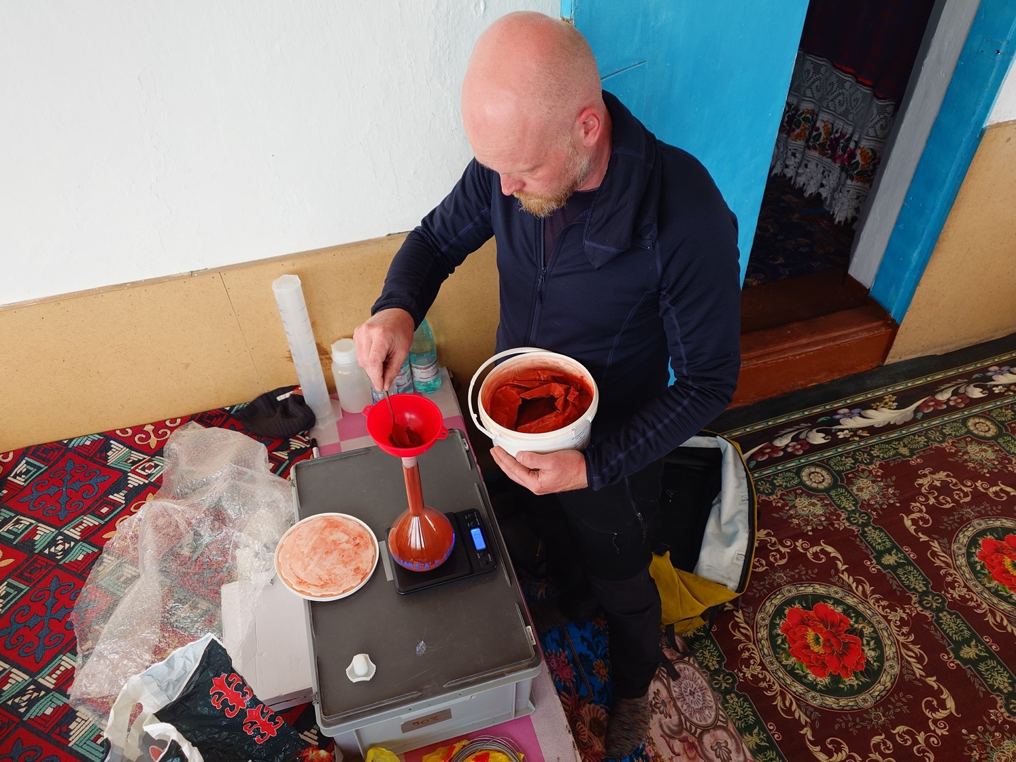
Figure 2: Creating 50 g/L base solution. Scale, mixing flask, tracer (here Sodium-Fluoresceine), funnel, and spatuala/spoon are required. A place without sunlight, and no air flow are required as well.

Calibration vials
This step requires the most attention. It is extremely important to work as precise as possible. The base solution has now a very high concentration (50 g/L). The instrument (FL30) measures in the ppb (µg/l) range with a maximum range of 0-200 µg/L and a precision of up to 0.1 ppb. The base solution (50 g/L) has a concentration of 50*1000*1000 µg/L. This requires to dilute the base solution sufficiently to use it as calibration liquid. The Excel file 05 - Lab preparation v 2025-07-15 [EN].xlsx helps us to determine how to do this.
On the first spreadsheet, we see marked cells in red. These cells are the ones we have to fill out. Depending on how strongly we dilute the base solution and the folowing solutions , we can use either two or three dilution steps. The less liquid we use from a previous solution, the stronger we dilute. But this also means that we get a stronger relative error/precision. In Figure 3 you see an example where we use 2 dilution steps. The third column (S3) says “collected mass (g)” is 1000 g. This means we use all of S2 to be diluted in step S3 with a final solution volume of 1000 g. Because we already have 1000 g from S2 in the flask, this means there is no dilution happening. You can see also that the resulting (“current concentration” field) concentration is the same for S2 and S3 (Figure 3).
The first cells require the measured amount of tracer that we used for the base solution (here 100.3 g). I used the scale to also determine the density of that solution (“Base solution/Standard density” – 1.0403 kg/L). The bucket volume serves to identify how much final calibration liquid we should fill into the vials.
The Excel sheet will help you to check the theoretical concentration. You can, before you start the dilution process, fill in values (red cells) for the “Collected mass (g)” to see how much color you have to dilute each step to reach a final concentration of around 2 mg/l (Cell “Concentration (mg/L)”). The additional cells (not shown in Figure 3) on the right-hand side in the Excel sheet show how much liquid of the final solution you will have to fill in the calibration vials. You want to aim for a value between 10 and 50 ml. In the current example, we use the lowest amount – we should not aim for less because the measurement error from the precision scale will increase.
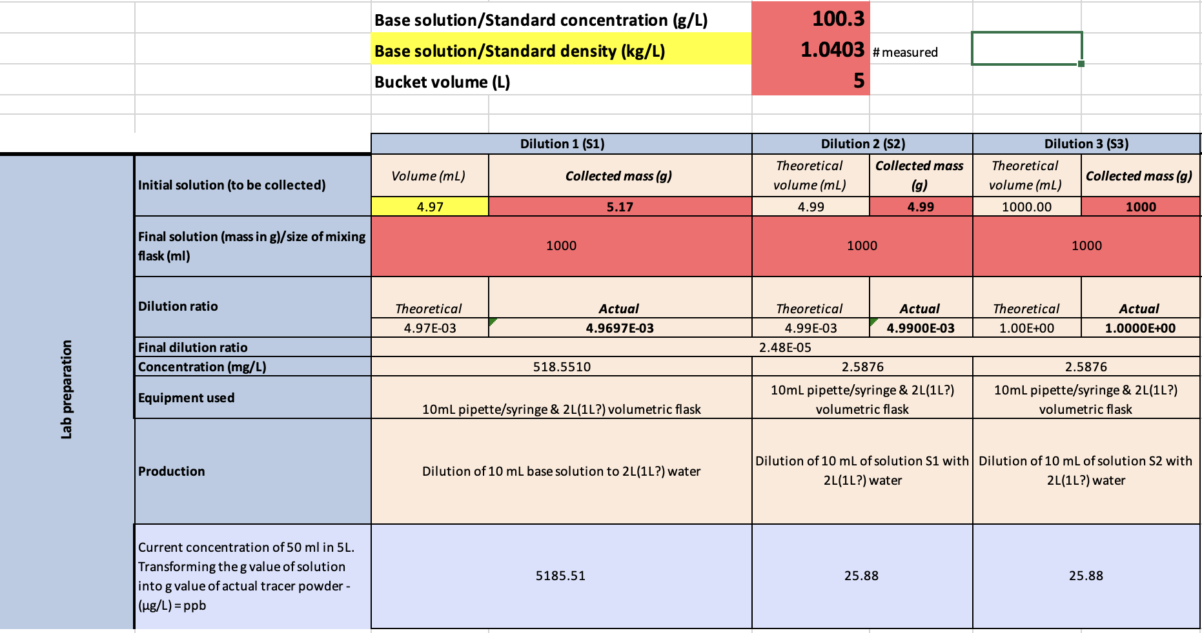
Figure 3: Calibration vials help sheet (05 - Lab preparation v 2025-07-15 [EN].xlsx). Red cells need to be filled out by the user. The three main sections (Dilution 1”S1”, Dilution 2”S2”, Dilution 3”S3”) are the dilutions we obtain by mixing a measured amount (mass) of the previous solution (base solution for S1, otheriwse the previous step, e.g. from S2 for S3). The “Final solution” cells indicate the size of the mixing flask, e.g. 1000 for a 1L mixing flask. You can also provide the bucket volume that you will use in the field for the calibration – this will directly provide you with an estimate of how much liquid you will have to use per calibration vial later on. All other fields simply show the resulting concentrations in your diluted liquid – this requires no editing!

Dilution Step 1 (S1)
These are the processing steps for the first dilution:
- Calibrate the precision scale
  - Turn scale on and press the button for calibration – on the Pesola precision scale this is holding the “M” button for 5 seconds
  - You will be asked to place 100 g weight on it – do so
  - You will be asked to place 200 g weight on it – do so
  - You should get the confirmation that the calibration has worked
  - Test it! Place a 100 g weight on it, does it show 100.00 g?
    - If not, make sure the scale is level
    - The precision is 0.01 g, so a weight of 100.01 g or 99.99 g are fine
    - If not, repeat the calibration
- Use the precision scale and place an empty 50 ml vial on it (cap removed).
- Set to 0 (Tare)
- Turn, gently shake the base solution to ensure it’s properly mixed
- Use the clean syringe with needle to take around 6 ml of liquid from the base solution
- Fill liquid into the vial on the scale until you reach around 5 g (it can be a bit more or less)
- Note down the value into the Excel sheet into the cell “Collected mass” of S1. In Figure 3, you see a value of 5.17 g.
- Fill the mixing flask to exactly 1L
  - Prepare slightly less than 1L in the 1L cylinder (~0.95L)
  - Add slowly (to prevent bubbles) water using the 1L cyclinder
  - Fill the last bit by using the squirt bottle so the miniskus in the mixing bottle has its lowest point on the marker
- Add the cap and mix properly. You can turn the bottle up and down. Ensure it’s properly mixed
- Fill the liquid into an empty wide neck bottle (1L) (we will use only 5 ml from it)
- Clean the mixing flask
- Clean the syringe and needle
- Clean the 50 ml vial

The concentration of S1 can be seen in the Excel file in the field “Concentration (mg/l)”.

Dilution Step 2 (S2)
These are the processing steps for the second dilution:
- Use the precision scale and place an empty 50 ml vial on it (cap removed).
- Set to 0 (Tare)
- Turn, gently shake solution S1 to ensure it’s properly mixed
- Use the clean syringe with needle to take around 6 ml of liquid from S1
- Fill liquid into the vial on the scale until you reach around 5 g (it can be a bit more or less)
- Note down the value into the Excel sheet into the cell “Collected mass” of S2. In Figure 3, you see a value of 4.99 g.
- Fill the mixing flask to exactly 1L
  - Prepare slightly less than 1L in the 1L cylinder (~0.95L)
  - Add slowly (to prevent bubbles) water using the 1L cyclinder
  - Fill the last bit by using the squirt bottle so the miniskus in the mixing bottle has its lowest point on the marker
- Add the cap and mix properly. You can turn the bottle up and down. Ensure it’s properly mixed
- Fill the liquid into an empty wide neck bottle (1L) (we will use only 5 ml from it)
- Clean the mixing flask
- Clean the syringe and needle
- Clean the 50 ml vial

The concentration of S2 can be seen in the Excel file in the field “Concentration (mg/l)”.

Dilution Step 3 (S3)
In our example we have now reached a concentration of around 2.5 mg/L. This is the highest concentration possible. A good concentration would be around 1 mg/L, but this should be achieved with a three-step dilution. For our two-step dilution, we are done with the preparation of the liquid. It will look similar to Figure 4.
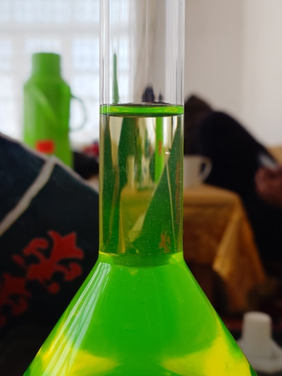
Figure 4: Calibration liquid of around 2.5 mg/L.
IF you want to do, or need a third dilution step, these are the processing steps for a third dilution – they are identical to step two except that you take the material from S2 instead of S1. If you are done with the dilution just fill in 1000 ml into the field at S3 “Collected mass (g)”:
- Use the precision scale and place an empty 50 ml vial on it (cap removed).
- Set to 0 (Tare)
- Turn, gently shake solution S2 to ensure it’s properly mixed
- Use the clean syringe with needle to take X amount (identify how much you need using the Excel table) of liquid from S2
- Fill liquid into the vial on the scale until you reach around X amount (it can be a bit more or less)
- Note down the value into the Excel sheet into the cell “Collected mass” of S3.
- Fill the mixing flask to exactly 1L
  - Prepare slightly less than 1L in the 1L cylinder (~0.95L)
  - Add slowly (to prevent bubbles) water using the 1L cyclinder
  - Fill the last bit by using the squirt bottle so the miniskus in the mixing bottle has its lowest point on the marker
- Add the cap and mix properly. You can turn the bottle up and down. Ensure it’s properly mixed
- Fill the liquid into an empty wide neck bottle (1L) (we will use only 5 ml from it)
- Clean the mixing flask
- Clean the syringe and needle
- Clean the 50 ml vial
The concentration of S3 can be seen in the Excel file in the field “Concentration (mg/l)”.

Filling the calibration vials
In the Excel file you see in purple the expected concentration of color in the mixing bucket when adding the calibration vials. These values consider that the specified amounts (right-hand side of the table; not visible in the figure) are mixed in the 5L bucket. For our actual discharge experiments, where we inject color into the river, we aim to measure in the range 5-20 ppb. So during the calibration, we also aim to reach a concentration in that range. In the Excel file you see estimates for the first three calibration vials of around 4, 8, and 12 ppb. That is perfectly in the range; it can be a bit higher or lower, but you want optimally one point at the lower end (5 ppb), one at the higher end (20 ppb), and one in the middle.
You can check how much liquid you need per calibration vial by changing the value in the red field “Collected mass (g)” for each of the “CALIBRATION FLUID 1-3”. This should be the same value for all calibration liquids!
Steps to fill the calibration vials:
- Use the precision scale and place an empty 50 ml vial on it (cap removed).
- Set to 0 (Tare)
- Either option is possible now:
  - Fast version (requires a steady hand)
    - Use a 100 ml cylinder and fill it 2/3
    - Pour around X amount of color (the amount you have determined in the Excel file under “Collected mass (g)” for the CALIBRATION LIUQID 1 into the vial
    - Make sure to NOT spill any liquid on the scale !
    - You can take the vial in your hand, off the scale, to pour the liquid and then place the vial back on the scale
    - You can use the volume indicator on the vial to see how much you poured (ml ≈ mg)
  - Slow version: Use a clean syringe with needle to take around X amount of color (the amount you have determined in the Excel file under “Collected mass (g)” for the CALIBRATION LIUQID 1
- Write the amount (g) on the calibration vial. Use a permanent waterproof marker for this!
- Close the cap tighly
- Repeat until you have filled all vials
- Store all vials in an opaque (light proof) bag
- Store the bag in a fridge if you are preparing the color several days before the field campaign

Required materials and tools for the preparation of calibration vials:
- Mixing flasks (2 times (if possible) 1L or 2L) with caps
  - If you have only one mixing flask you will have to move the solutions to another bottle because you will need the mixing flask multiple times.
- Precision scale (0-100 g, with 0.01 g precision)
- Calibration weights for the precision scale (2 x 100 g)
- Syringe with syringe needle (facilitates measuring small amounts of liquid)
- ~40 times 50 ml vials (empty) – this can in principle be any kind of chemistry plastic bottles (PP, PET) with a screwable cap, and that are small enough to place on the precision scale. Aim for at least 3 vials per measurement. For a field campaign at one site, with 8 measurements, you will need (8 x 3 = 24). Take some spare ones! We also need these bottles to measure the amount of base solution we fill into the next dilution mixing flask. And we need the vials to store the injection liquid (base solution).
- Computer with the Excel sheet 05 - Lab preparation v 2025-07-15 [EN].xlsx
- 1L cyclinder
- 100 ml cylinder

Injection vials (for the actual measurements)
To measure the discharge, we need to inject the color/dye into the stream (upstream) and measure its concentration (downstream) with the FL30. The amount of injection mass depends on how much water is flowing in the river. In the Excel sheet 05 - Lab preparation v 2025-07-15 [EN].xlsx in the speadsheet called (“Help on injection preparation”) you find an estimation sheet of how much color is needed depending on the discharge and the travel time of the color. If you have performed already some experiments, you should have an idea of these two parameters. If you do not have such estimations, choose a 600 seconds (10 minutes) travel time. Small glaciers like Batysh Sook have around 0.1 to 1 m³/s, large glaciers like Abramov have around 1 to 15 m³/s. You can combine multiple injection vials if you find that the color amount is insufficient to get a strong enough signal (>5 ppb). On the contrary, you cannot split a vial in which you have too much color. Therefore, preparing rather more small vials is better than having a few large vials.
If the values in the Excel sheet are not corresponding to you glacier site, you can set the upper and lower boundaries for travel time and discharge in the red cells. The table will automaticall update.
The vials are filled in the same way you fill the calibration vials. Instead of using the calibration liquid you now use the base solution:
- Use the precision scale and place an empty 50 ml vial on it (cap removed).
- Set to 0 (Tare)
- Either option is possible now:
  - Fast version (requires a steady hand)
    - Use a 100 ml cylinder and fill it 2/3 (base solution)
    - Pour around X amount of color (the amount you have determined in the Excel file under “Help on injection preparation” into the vial
    - Make sure to NOT spill any liquid on the scale !
    - You can take the vial in your hand, off the scale, to pour the liquid and then place the vial back on the scale
    - You can use the volume indicator on the vial to see how much you poured (ml ≈ mg)
  - Slow version: Use a clean syringe with needle to take around X amount of color (the amount you have determined in the Excel file under “Help on injection preparation”)
- Write the amount (g) on the injection vial. Use a permanent waterproof marker for this!
- Close the cap tighly
- Repeat until you have filled all vials*:
  - If not sure how much color you need, you can use twice as many vials as planned measurements
  - If you see in the field that the tracer amount was insufficient, you can combine two or more to reach a good singal strength
- Store all vials in an opaque (light proof) bag
- Store the bag in a fridge if you are preparing the color several days before the field campaign
If you have not prepared enough vials, you can fill up new vials in the field. This can be complicated if it is windy and you have no plane ground to place the scale. It is very important in that case to check if the scale is properly displaying the weight! You should also perform a calibration! You should also have a sun-protected place (behind a very big boulder or in the camp inside a tent) !

